
Contents
1.Introduction 3
2. Problem Analysis 3
3. Proposed Solution 3
4. Requirements Analysis 3
4.1Functional Requirements 4
4.2 Non-Functional Requirements 4
5. Use Case Diagram 4
6.Activity Diagram 6
7. Class Diagram 7
8.Database Design 9
8.1 Normalization 9
9.User Interface Design 12
• Login Page: 12
• Register Page 13
9.1 Student 14
• Home Page: 14
• Search Books 15
• Borrow Book 16
• Return Book 17
• Pay Fine 18
• Account Status 19
9.2 Librarian 20
• Dashboard 20
• Issue Book 21
• Book Management 22
• Member Management 23
• Notifications Page 24
10.Design Patterns 25
11.Technological Stack 25
12.Future Improvements 25
13.Conclusion 25
14. References 25

Table Of Figures
Figure 1: Use Case Diagram 6
Figure 2: Activity Diagram 7
Figure 3: Class Diagram 9
Figure 4: ER Model 12

1.Introduction
A Library Management System (LMS) is a computer application that is used to perform automated and record keeping of all crucial library activities including keeping of records of books, library members, and records of borrowings. The system can streamline the efficiency, increase the accuracy, and improve the integrity of the data and minimize or decrease the manual labor and human error by digitizing these processes (Borgman, 2000). The proposed system will be created with Java because it has a platform-independent nature, robustness, and object-oriented capabilities, which allow to create reliable and maintainable applications (Deitel & Deitel, 2018).

2. Problem Analysis
In most libraries, the books are still managed using manual means such as paper records or registers. A number of issues are brought forth by this system. The books can be lost or misplaced easily as it cannot be accurately tracked. It is also difficult to find a book as it lacks a rapid searching process. Opportunities of human mistakes during writing or records updating are also numerous. Such errors may result in incorrect information regarding the availability of books, dates of issues and dates of returns. More to the point, fine calculating can be flawed because there is no information or information is not precise. The manual system, in general, is slow, inefficient, and has an influence on the quality of library services.

3. Proposed Solution
To address the issues of manual record keeping, we will create a Java based library management system. The system will store all the details about the books like title, author and the availability status. It will monitor the information of borrowed books through capture of issue and return information. The system will also have a quick search feature where one can identify books quickly. It will also store the information of the members such as names and contacts. This electronic system will enhance the faster, more precise and efficient way the library functions.

4. Requirements Analysis
What: The system must enable the librarian to add books by keying in the information like title, author, category, and ISBN and the number of copies.
Why: This is necessary so that the library database can be updated every time there is a purchase or donation of books.
Important: It makes the book collection easy to track, search, and manage as it is ensured that all books are duly recorded.

4.1Functional Requirements
  - Add new books
  - Delete books
  - Update book details
  - Issue book
  - Return books

4.2 Non-Functional Requirements
- Easy to use
- Fast
- Secure
- Reliable

5. Use Case Diagram
Use Case Diagram is employed to indicate the interaction of the user with a system. It is a graphic model of actors (users) and system functions. It is taken to simplify requirements and explicitly indicate who does what. It is significant as it enhances communication, minimizes confusion and aids in designing better systems.
Actors
- Librarian
- Student
Use Cases
Librarian
- Issue Book
- Manage Books
- Modify Books
- Calculate Fine
- Manage Members
- Send Notification

Student
- Search Book
- Borrow Books
- Pay Fine
- Check Acct Status
- Return Book
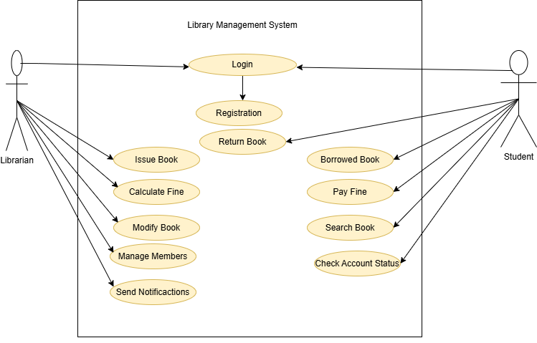
Figure 1: Use Case Diagram

6.Activity Diagram
One of the UML (Unified Modelling Language) diagrams is known as an activity diagram, which is used to represent dynamic or workflow of a particular system, process or operation. It is interested in the sequence of the activities and control flow among the activities. Take it as a way of picturing the way things occur in a chronological way.
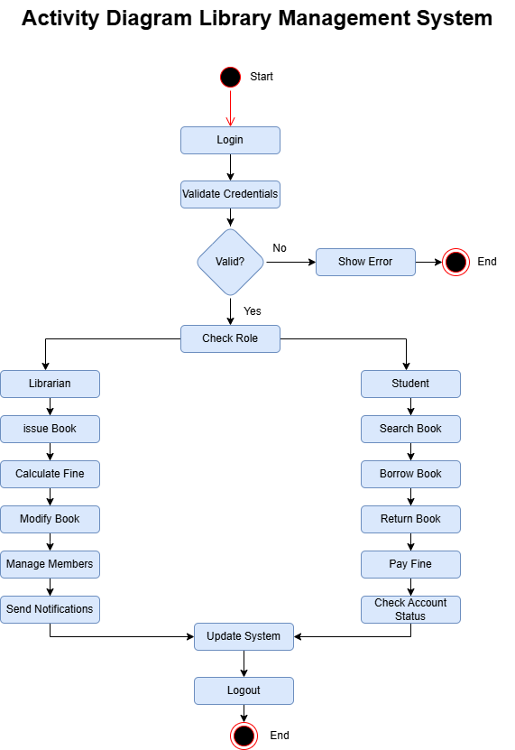
Figure 2: Activity Diagram
7. Class Diagram
Class Diagram is presented to demonstrate the organization of a system. It is a representation of classes, their character (data), procedures (functions), and associations among classes. It is applied to design and learn the way various components of the system are structured and interrelated. The reason is it assists in system planning, the correct writing of code and a clear design.
Main Classes
User
- User ID
- Name
- Email
- Password
- Phone
- Address
Librarian
- Librarian ID
Student
- Student ID
- Department
- Enrollment Year
Book
- Book ID
- Title
- Author
- Publisher
- Publication Year
- Total copies
Fine
- Fine ID
- Issue_Date
- Return_ Date
- Status
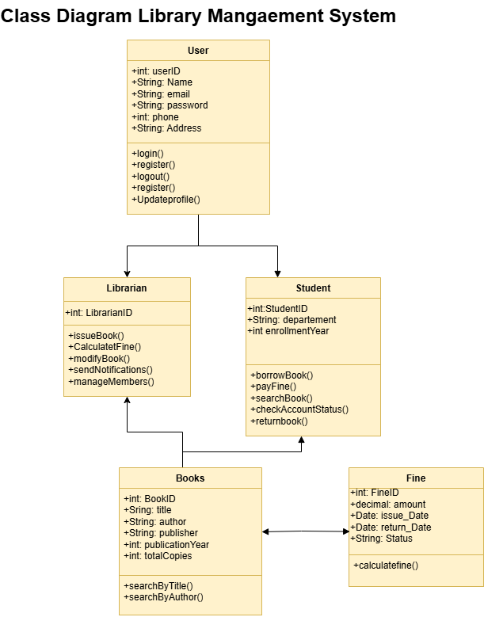
Figure 3: Class Diagram

8.Database Design
Database design refers to the process of formatting data so that it can be stored, retrieved and managed effectively.

8.1 Normalization
Normalization is a database design method that is used to group data into organized tables and diminish redundancy, avoid anomalies on insert, update and delete operations, data integrity through adequate links and dependencies.
1.1NF (First Normal Form)
- Library
user ID (PK) | name | email | password | phone | address
department | enrollment Year | Student ID | librarian ID | book ID | title
author | publisher | publication Year | total Copies | fine ID | amount
Issue_date | return_ Date | status

8.2NF (Second Normal Form)
- Users
user ID (PK) | name | email | password | phone
address

- Students
Student ID (PK) | user ID (FK) | department | enrollment Year

- Librarians
librarian ID (PK) | User ID(FK) | Book ID (FK)

- Books
book ID (PK) | title | author | publisher
Publication Year | Total Copies | Fine ID | amount
Issue_Date | Return _date | status

8.3NF (Third Normal Form)
- Users
user ID (PK) | name | email | password | phone
address

- Students
Student ID (PK) | user ID (FK) | department | enrollment Year

- Librarians
librarian ID (PK) | User ID(FK) | Book ID (FK)
- Books
book ID (PK) | title | author | publisher
Publication Year | Total Copies
- Fine
Fine ID(PK) | Book ID(FK) | Student ID(FK) | Librarian ID(FK)
Issue_Date | Return _date | status | Amount

8.4 Entity-Relationship Model (ERM)

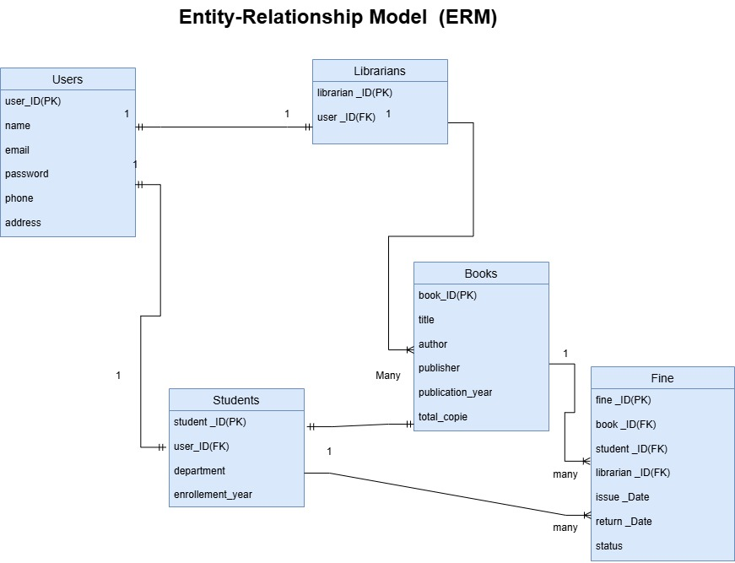
Figure 4: ER Model

9.User Interface Design
The concept of the User Interface (UI) design refers to the creation of the visual representation and interactive elements of digital products with the focus on the simplicity, consistency, and usability that enable users to navigate and interact with software, websites, or applications effectively and pleasant enough.
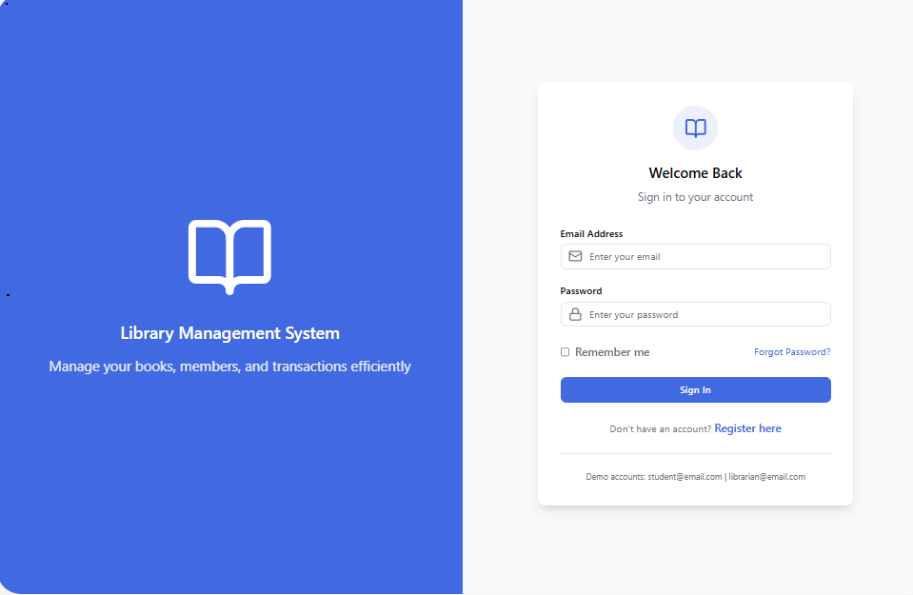
- Login Page: The Login Page helps registered individuals to log into the system safely by typing in their information. It allows the authentication of the systems and secures system data against unauthorized access.

- Register Page: Registration Page is where registered users create a new account and fill in details that include name, email and password. It assists in keeping proper records of the members in the system.

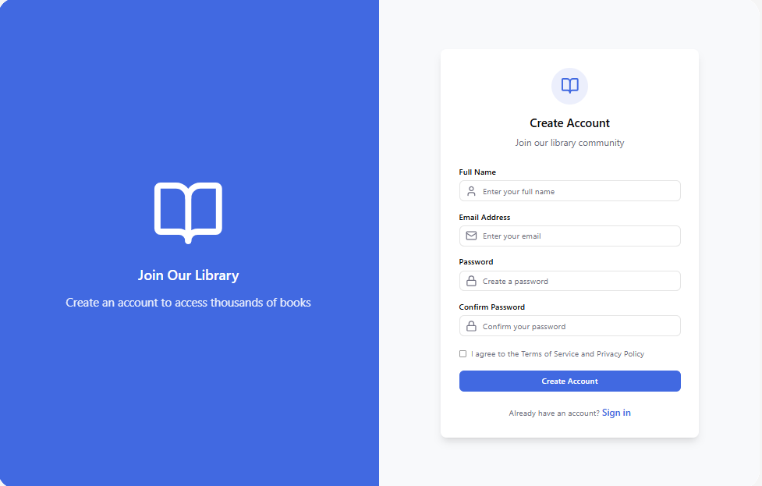

9.1 Student
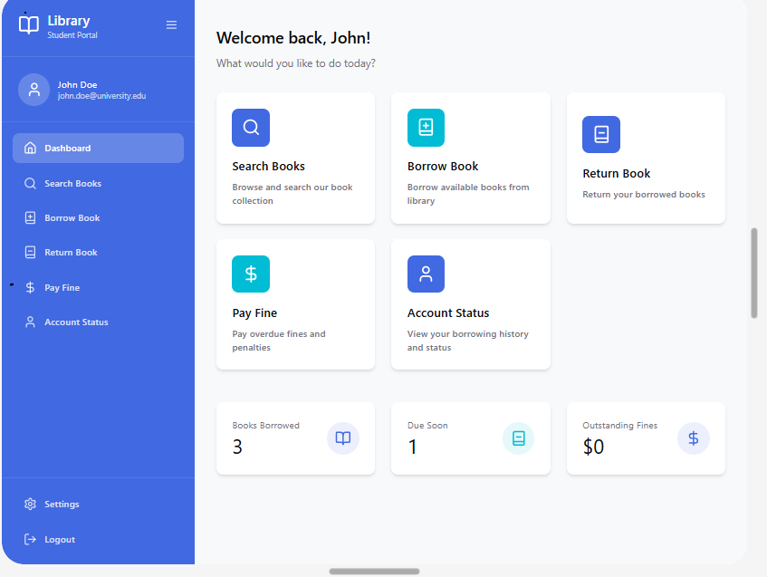
- Home Page: The Home Page is the central point of entry of the system. It gives the summary of important data including total book, borrowed books, pending returns, and notices. It enables users to be able to move to various modules fast by use of the sidebar menu.

- Search Books: The Search Books Page lets the person locate books through the filter of title, author or category. It enables users to find resources that are available quickly in the library.

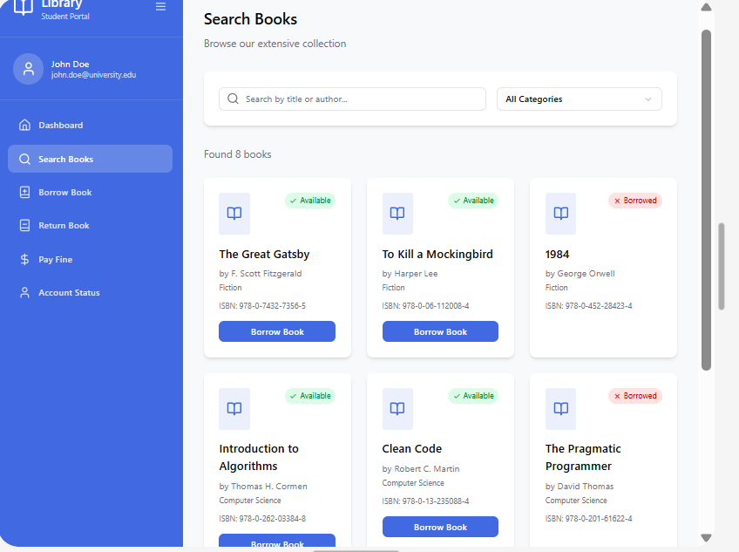

- Borrow Book: The Borrow Book Page is a product through which students can borrow and request available books. It also shows information on books and their availability and then takes the act of borrowing.

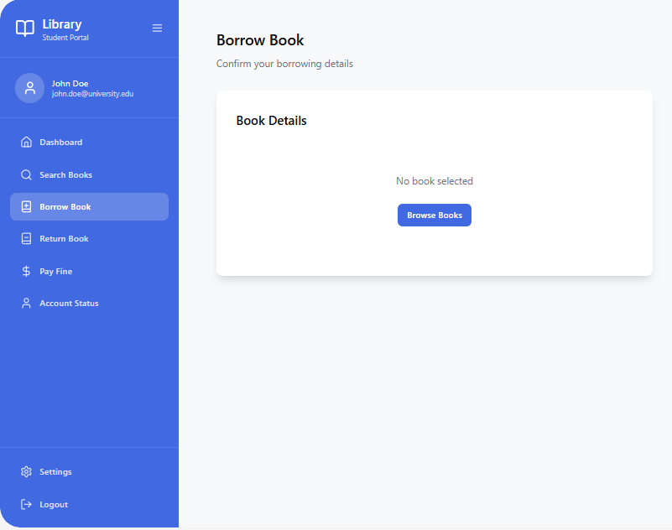

- Return Book: The Return Book Page will enable the users to given back already borrowed books. It makes changes in the system records and fines are computed in case the book is returned beyond the due date.

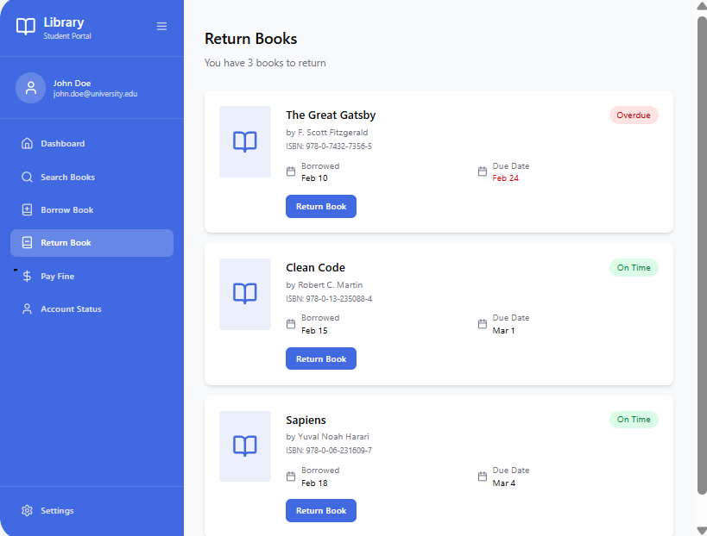

- Pay Fine: The Pay Fine Page enables the students to see and pay outstanding fines. It guarantees proper payment tracking and updates the state of the account of the user.

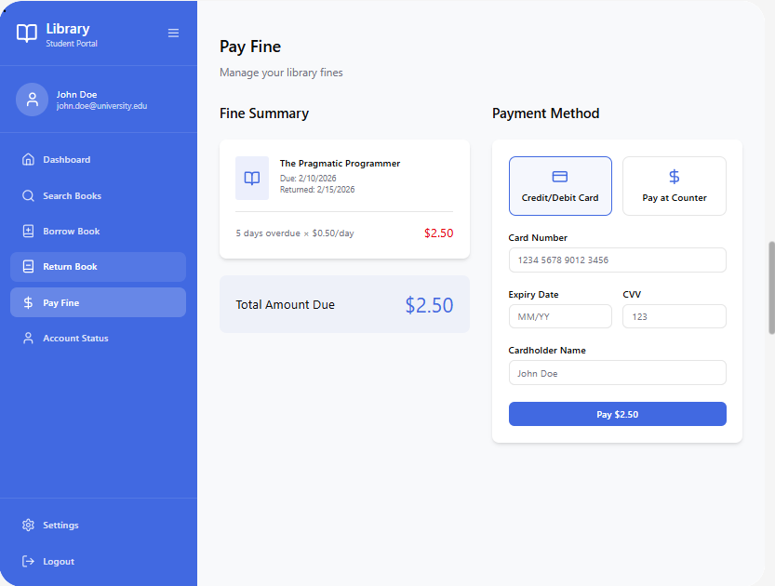

- Account Status: The Account status page shows user related data such as books borrowed by the user, fines, due dates etc. It assists the users in keeping track of their library activities.

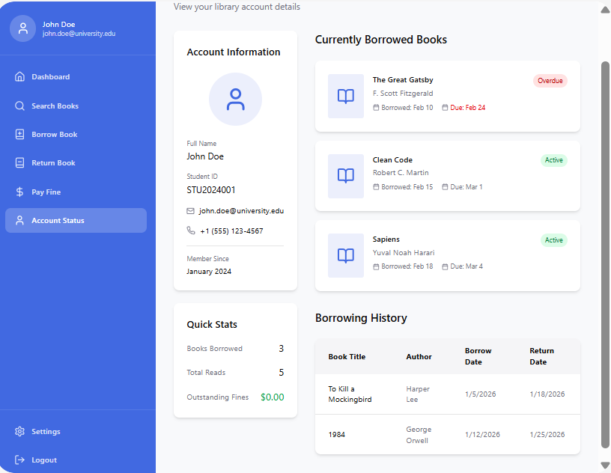

9.2 Librarian

- Dashboard: The Librarian Dashboard is the administrative controls that are used to manage the library operations. It has the faculties of book issuance, updating book specifications, membership management and notification.

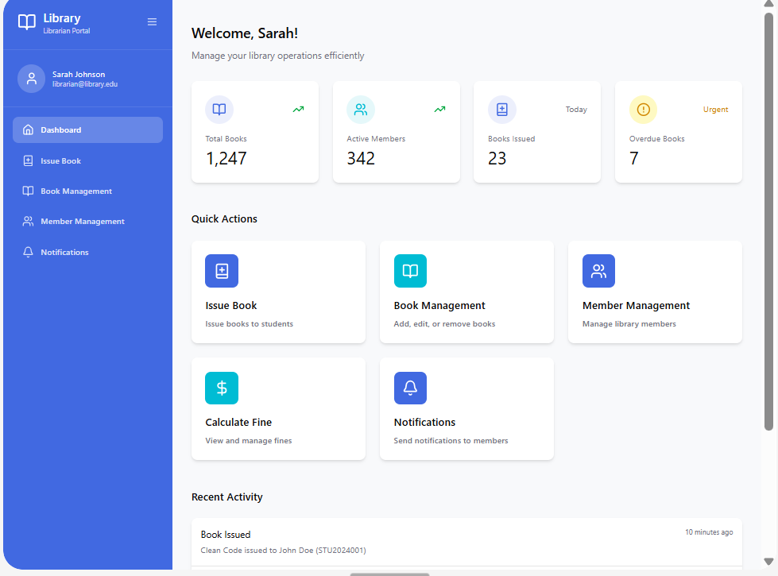

- Issue Book: Issue Book Page enables the librarians to allocate the books to students. It checks availability and updates in the system of borrowing records.

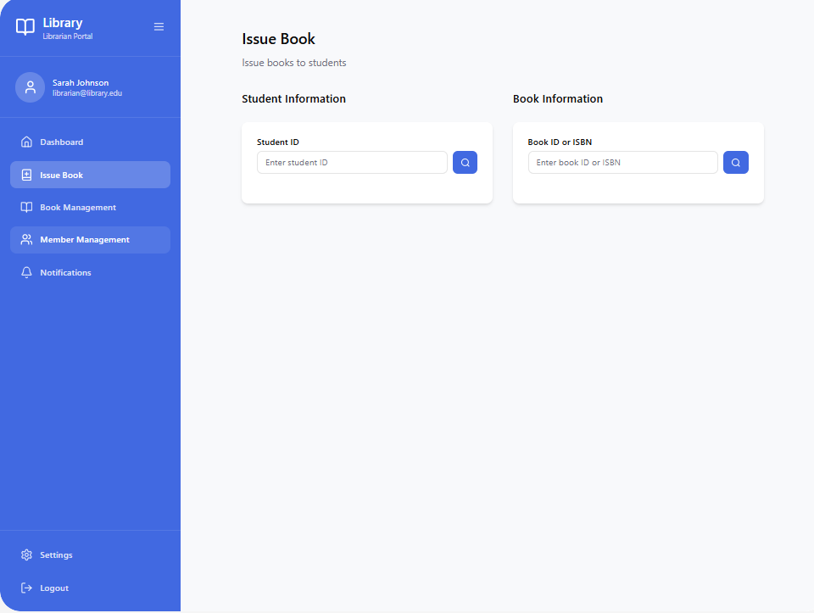

- Book Management: The Book Management Page enables the librarian to manage the resources of the library easily. It gives an option of adding new books, updating book details and deleting books in the system. This page makes sure that the catalog of books is properly maintained.

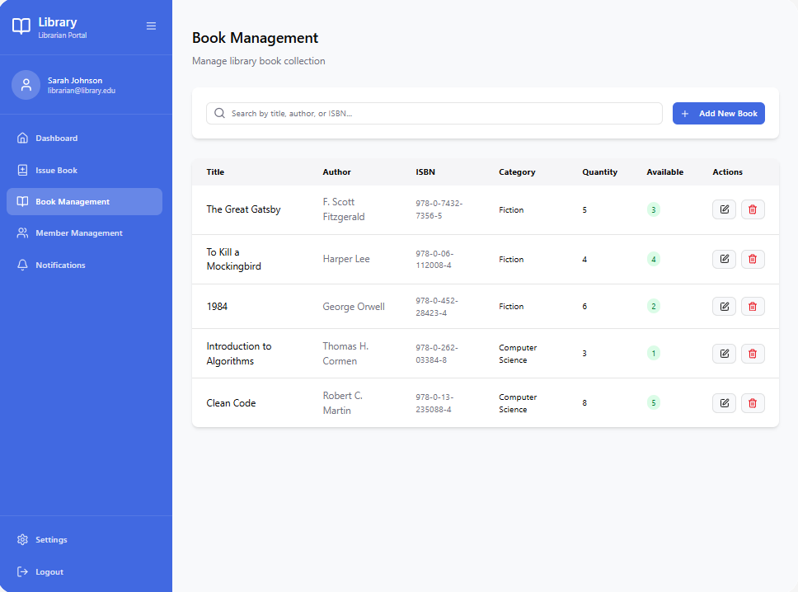

- Member Management: Member Management Page allows the librarian to control registered users. It enables the addition of new members, updating the information of the members, as well as the removal of inactive members. This page can be used to keep accurate records of the members in an organized manner.

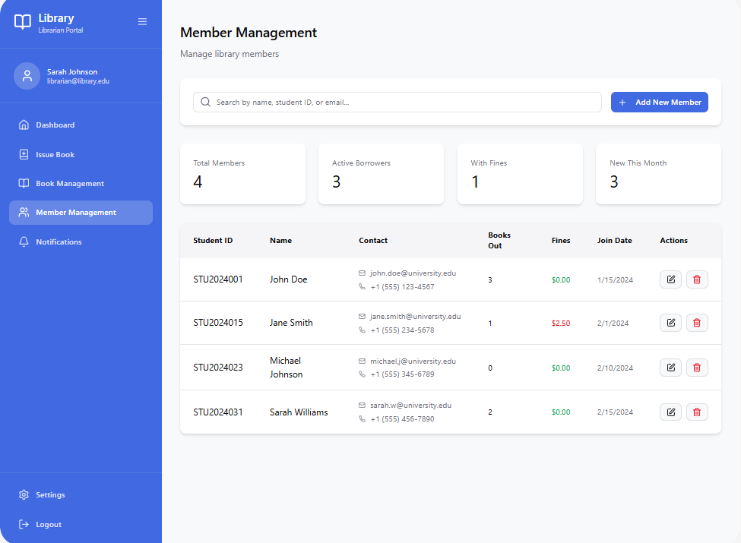

- Notifications Page: The Notifications Page gives the librarian the ability to notify users about crucial alert and update messages. It can be used to convey information like due date reminders, overdue message and general announcements to enhance user awareness and interaction.

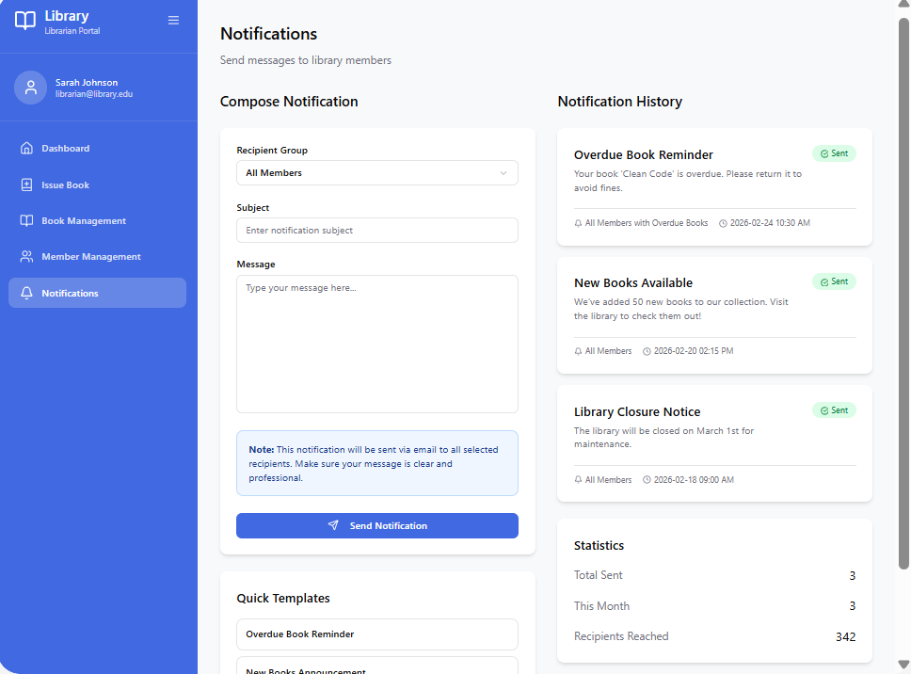

10.Design Patterns
The Library Management System is made according to the MVC architectural pattern with the Model doing all the operations, data, and business logic clearly connected with the database, View presenting the information and user interface and the Controller receiving the user input, arranging interactions between the View and the Model and performing operations like borrowing, returning or search the book. Also, the system uses the Singleton pattern to control the database connection whereby only one is created and shared across the application to utilize the resources efficiently and provide a consistent access.

11.Technological Stack
- Designed: Figma
- Backend: Java (Servlets or Spring Boot)
- Database: MySQL
- Development Tools: VS Code, MySQL Workbench

12.Future Improvements
One can improve the system in the future by incorporating new features like online book reservation, autonomous email to remind due dates, and connection with barcode scanners to ensure that the book issuance and return can be made faster and efficient.

13.Conclusion
Application of this Library Management System will simplify the library operations in terms of speed, accuracy and easier management and lessen errors and enhance satisfaction among users.

14. References
Borgman, C. L. (2000). From Gutenberg to the Global Information Infrastructure: Access to Information in the Networked World. MIT Press.
Deitel, P., & Deitel, H. (2018). Java: How to Program (11th ed.). Pearson.

